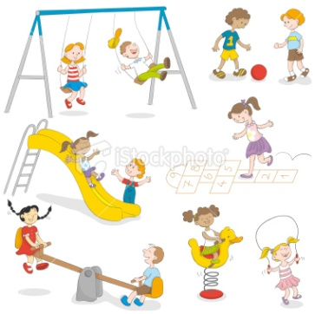**The past progressive**

During Eid days we didn’t come to school, we weren’t studying, we were celebrating.

past

now

Started something

I was doing

Finished something

An action that was **in progress** “going on” at a certain moment in the past.

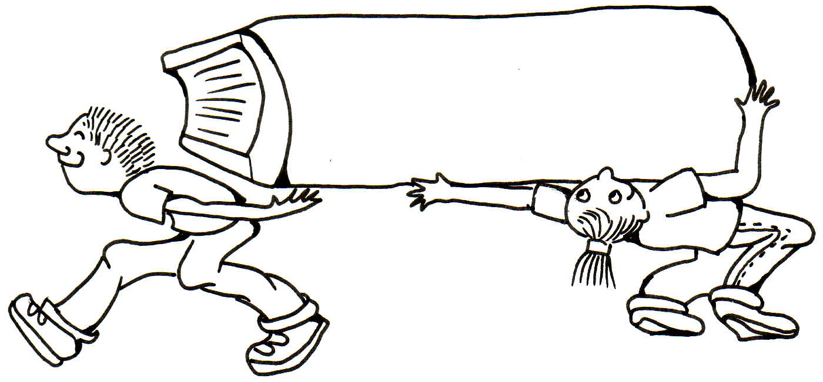

The past progressive form needs the helping verb **be** in the past (**was /were**).



Verb to be



Subject



Verb+ing



were



The kids



carrying

the big heavy book. bly sive form needs a helping verb what you were doing during a period of time in the past.

**The past progressive negative**



notbly sive form needs a helping verb what you were doing during a period of time in the past.



Verb to be



Subject



Verb+ing



notbly sive form needs a helping verb what you were doing during a period of time in the past.



were



The kids



walking

comfortably