ATHS GRADE 9 ENRICHMENT PROJECT
TEACHER AND STUDENT INSTRUCTIONAL BOOKLET
2010-2011

Overview of the Enrichment Project
Welcome students and teachers, to ATHS’S grade 9 Enrichment Instructional booklet. Please refer to the bottom table of contents for information, instructions and rubrics concerning the project.
Topic Page
Introduction to the Grade 9 Enrichment Project
Semester 1: Introduction to Becoming an IT Technician
Evaluation 1) Vocabulary Activity 1 4
Evaluation 2) PowerPoint IT Career Presentation 6
Evaluation 3) Summary of IT Career 13
Evaluation 4) Field Trip/Hotel Worksheet Analysis 17
Evaluation 5) Hotel Logo and Mission Statement/ Presentation 18
Semester 2: Analyzing the Problems at Seaside Hotel
Evaluation 1) Reflection and Vocabulary Semester 2 23
Evaluation 2) Customer Needs Analysis Email 27
Evaluation 3) Hotel Brochure 29
Evaluation 4) Website Analysis 31
Evaluation 5) Hotel Website/Presentation 35
Semester 3: Creating Solutions 38
Evaluation 1) Reflection and Vocabulary Semester 3 39
Evaluation 2) Flow Chart of IT Systems 43
Evaluation 3) Excel Salary Worksheet 45
Evaluation 4) Report Writing Format/Appendix
Evaluation 5) Finalized Hotel Report/Presentation

Introduction to the Grade 9 Enrichment Project
This booklet is designed to provide teachers and students a guide to the major evaluations students are to be assigned during the course of the year. The year is divided into three separate semesters and corresponding assignments are to be completed within the timeframe of each semestered cycle. Teachers are encouraged to teach the ideas and concepts regarding each major form of evaluation so that students are well aware of their expectations.
Objective of the Project
The enrichment project introduces the career if IT technicians, and leads into a case study where students are to improve and modernize an existing hotel through the eyes of an IT technician. The objectives of this project are to:
- Introduce the IT Career to Students
- Students are to be immersed in various forms of technology in completing their tasks
- Students are to be introduced to new vocabulary and concepts regarding the IT Career and Hotel Service Industry
- To provide a package which will assess and improve student English writing, reading, speaking, grammar and listening skills
- To introduce the concept of report writing and how present collective information
- To build on student teamwork and individual skills within a safe and cooperate environment
- To initiate interest and self confidence in their English language skills
Evaluation of the Project
Students and teachers are recommended to view the rubrics that are provided with each evaluation. Each rubric will identify the specific tasks that need to be completed for each assignment. Teachers and students are encouraged to work together and conference frequently throughout the year, so that improvements can be made to follow up assignments. This process of improvement should be noted and reflected through the student’s evaluation.
Due Dates and Plagiarism Policy
All assignments are due on the due date provided. If work is not completed on the given due date, the teacher may deduct marks or assign a mark of 0. Students are required to be on time, work during class work periods, and be prompt to class.
All marks assessed for each assignment may include a 10% participation mark. Students will be marked how well they work in class and their overall attendance.
Any assignments which have cut/paste infringements or that have been copied from other students will automatically receive a mark of 0. During the beginning phases of semester 1, teachers will provide lessons and guides on how to avoid plagiarism.

Semester 1: Introduction to Becoming an IT Technician
Teachers are recommended to place students in groups of 4. While most of the evaluations are to be completed as a group, several of the activities will also require individual work. Teachers and students are recommended to work with students according to their learning ability and modifications to the groups can be made within the first semester.
These groups will be required to work together, exchange ideas and provide support for one another. Teachers and students are recommended to store all completed tasks on a hard disk to which both the teacher and student will have copies of all completed work. In addition, paper copies of these assignments is recommended and to be stored within the classroom at the teacher’s discretion.
Please write down the members of your group:
- __________________________________ 3) ______________________________________

- __________________________________ 4) ______________________________________

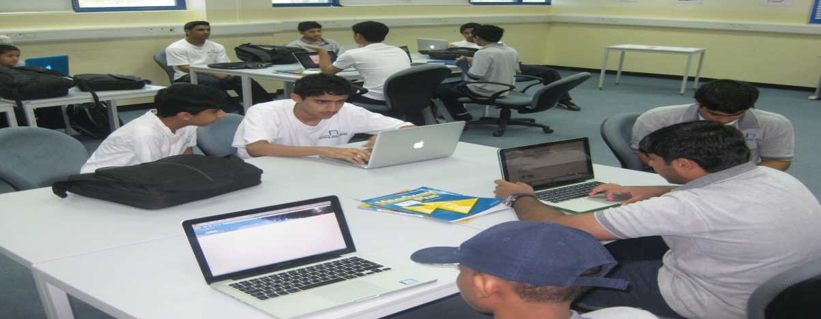
Evaluations for Semester 1:
Evaluation | Due Date | Marks
- Vocabulary Semester 1 | Sept 15 | 5 Marks
- PowerPoint IT Career Presentation | Oct 12-13 | 15 Marks
- Summary of IT Presentation | Oct 19-20 | 5 Marks
- Field Trip/Hotel Worksheet Analysis | Oct 30-31 | 10 Marks
- Hotel Logo and Mission Statement/Presentation | Nov 16-17 | 15 Marks
Total 50 Marks

Evaluation 1: Vocabulary Semester 1 (5 Marks)
(Due Date: Sept 15)
___________________________________________________________________
There will be many new vocabulary words introduced for semester 1. This is a list of several of the new words students will be required to know. Under each of the following vocabulary words, students are to write the definition of the word, and provide a sentence to which they clearly show they know the meaning of the word. Students are recommended to write their own definition of the word, rather than simply memorize a given definition from the dictionary.
Vocabulary Word |  | Part of Speech | Definition | Example Sentence
Ex. Scanner |  | Noun | A device used to scan a document and create a digital copy. | John used the scanner to copy his picture and store it into his hard drive.
Career
Occupation
Salary
Benefits
Moral
Currency
 | Cheque
 | Receipt
 | Slogan
 | Objective
 | Summary
 | Plagiarize
 | Facility
 | Advertise
 | Negotiate
 | Employee
 | Employer
 | Vacancy

Rubric:
Evaluation | Marks
- Definitions are accurate and written in the student’s own words  - Sentences show student’s understanding of the word  - Part of Speech is identified correctly | 1 2 3 4 5  1 2 3 4 5  1 2 3 4 5
Final | Total /15  Final Mark out of 5: /5

Evaluation 2: PowerPoint and Career Presentation (15 Marks)
(Due Date: Oct 12-13)
This second activity is designed to introduce careers, and more specifically, the IT career to students. Students are to read the articles and view the websites below, and then prepare a PowerPoint presentation. This PowerPoint will then be presented to the class in a formal oral presentation.
- What are the names of these occupations?
Below each picture, write down the job name. Look over your spelling.
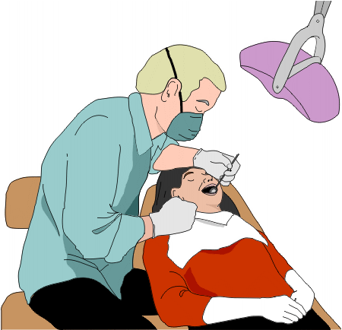
1) | 2) | 3)
 | 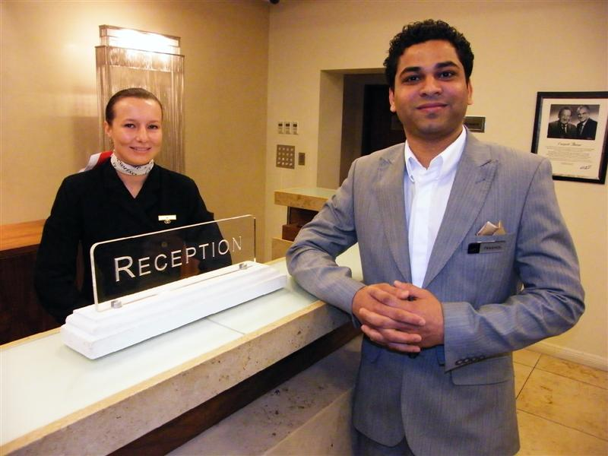
4) | 5) | 6)
7) | 8) | 9)

- What job would you like the most?
Ever wonder what Career you would like to have after high school? Have you ever thought about the perfect job? There are some easy ways to figure out what job you would like the most and be happiest with. Try this activity.

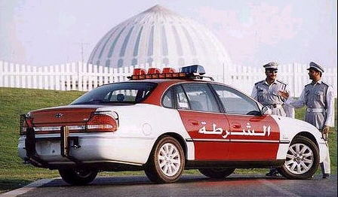
Directions:

- In the first column, write down 10 jobs you find interesting. They can be any job you can think of. (Ex. Policeman)
- In the next column, write down a number, between 1-10, rating which job you believe would be the most exciting. (Ex. 1= Least Exciting, 10=Most exciting)
- In the third column, write down a number, between 1-10, rating which job you believe would have the best salary. (Ex. 1=Least Exciting, 10= Most exciting)
- In the fourth column, write down a number, between 1-10, rating which job you believe would be considered the most respected. (Ex. 1= Least Respected, Most Respected)
- Add each row from left to right to calculate your final number. The job which has the highest total is the job you chose, as being the best for you.

OCCUPATION | Column 1- Most Exciting | Column 2- Best Salary | Column 3- Most Respected | TOTAL

The job with the highest total is: ________________________________________________________________

- ATHS Career Clusters and the excitement of Engineering.
At ATHS, students have the choice of working towards a certain goal. What job you wish to have after high school depends on what career cluster you wish to enter in.

ATHS Career Clusters & Educational Pathway
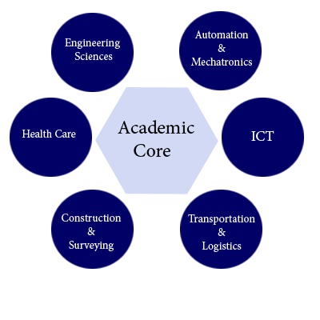
- What career cluster interests you most at ATHS? __________________________________

- What type of job would you like to have after high school? ____________________________

- In a paragraph between 5 to 10 lines, write down some career or life goals you have once you have completed high school. (Ex. Buy a nice, expensive car)

____________________________________________________________________________________

____________________________________________________________________________________

____________________________________________________________________________________

____________________________________________________________________________________

____________________________________________________________________________________

____________________________________________________________________________________

____________________________________________________________________________________

____________________________________________________________________________________

____________________________________________________________________________________

____________________________________________________________________________________

- A career in Engineering: What can it offer?

- Go to the website www.discoverengineering.org
- Enter onto the main page and click on “Video Activities”
- With your group members, choose any 3 of the videos listed on page and complete the following chart below.

Title of Video | What did you Learn About the Science of Engineering in this Video? | Where do you see this type of engineering science used in your community?

5. Avoiding Plagiarism (In Preparation for the Powerpoint)
What is “Plagiarism”?
Plagiarism is when you copy information from a computer or a friend and present it as YOUR OWN. This is also called “cutting and pasting” or “cheating” or even “stealing”.
Why is it important that students don’t plagiarize?
- Universities everywhere around the world consider cheating a major offense
- In many countries, copying and pasting from the internet is considered a crime
- As a student and human being, you have a moral responsibility to honestly try your best in life
How can a student use information from the internet and not copy and paste? Two Ways…
Option 1: Write the information you read in your OWN words | Option 2: Citing your Information
Ex. (Computer) Throughout the summer, tourists from Asia and Europe travel to the UAE to experience adventurous safaris and mountain tours.  Ex. (Student) In the summer months, many people travel to the UAE to go on desert rides and trips around the mountains. | Write the website or where you get the information in brackets after the last sentence.  Ex. Dubai is located south of the Persian Gulf on the Arabian Peninsula and has the largest population with the second-largest land territory by area of all the emirates, after Abu Dhabi. (http://en.wikipedia.org/wiki/Dubai)

Try to write the bottom paragraph in your own words. If you don’t understand a particular word, use a dictionary or have a teacher help you. Remember, that you do not need to rewrite ALL the ideas. Try your best!
INTERNET ARTICLE  Now Abu Dhabi is one of the most modern and richest cities in the world. The architecture of its modern buildings and sky scrapers is the finest in the Middle East. Abu Dhabi is one of the safest tourist destinations worldwide. Abu Dhabi city provides to tourists large gardens and parks, green boulevards lining all the streets and clean roads. |  | REWRITE BY STUDENT

6. PowerPoint Presentation of a Specific Occupation
Students are to join with their assigned groups and are now ready to prepare a Powerpoint describing one specific career. Please view the possible career choices below.
- Choose one of the jobs in the box.
PILOT NUCLEAR ENGINEER MILITARY

DOCTOR IT TECHNICIAN AUTO MECHANICS

DENTIST ROBOTICS ENGINEER POLICEMAN

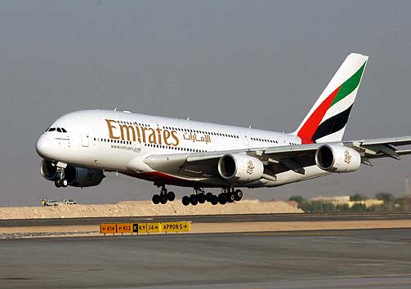 | 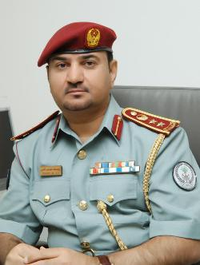 |  | 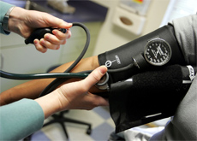

- Create the Powerpoint
Once you have chosen one of the jobs listed above, you are to create a Powerpoint which describes this job. Each member in your group will contribute to the Powerpoint presentation. Your presentation must have a slide which discuses each of these parts of the job:
- What are the skills you use daily in this job?
- What qualifications do you need?
- Why the job is important for society?
- What school subjects must you have and why?
- What are the main responsibilities in the job?
- Why is this job important for society?
In your presentations, you must include images, audio (sound) and all members of the group must take part. Ask your teacher to help you. Students are to be reminded not to plagiarize from the internet.
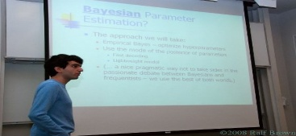

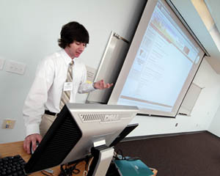
- Oral Presentation

Students will be required to present their Powerpoint presentation to the class the following week after the due date. Presentations should be between 5-10 minutes long and should involve each student from the group to present part of the Powerpoint.

When presenting in front of a class, students should try to follow these suggestions:
1 | Have a clear expressive voice and don’t mumble
2 | Speaking voice should be loud so that everyone in the room can hear you
3 | Stand straight
4 | Show excitement and care about your presentation
5 | Look at your audience- let them know you are speaking to them
6 | Try to stay away from reading notes- explain your information, don’t just re-read

Rubric:
Evaluation | Marks
Powerpoint  - Power point is creative and organized/Ideas are well presented  - All points are discussed on Powerpoint  - Spelling/Grammar  - Capitals/periods included  - No Plagiarism Bonus | 1 2 3 4 5  1 2 3 4 5  1 2 3 4 5  1 2 3 4 5  1
Oral Presentation  - Student has a clear and loud voice  - Student uses a variety of vocabulary words  - Student posture is proper and formal | 1 2 3  1 2 3  1 2 3
Final | Total /30  Final Mark out of 15: /15

Evaluation 3: Summary of IT Career (5 Marks)
(Due Date: 19-20)
One of the many exciting careers available through ATHS and further College/University training is being an IT technician.
This activity will help us better understand what it takes to become an IT Technician.
What does it take to be an IT technician?
- View the short video below, on what it takes to be an IT technician.
http://www.ehow.co.uk/video_5846801_become-computer-technician.html
- Read the following article on being an IT technician.
http://www.ehow.com/about_5377238_technician-job-description.html
- Search through the web to find another article which talks about being an IT technician. Write down some notes below of what you found out. Research information on IT technician duties, education, salary and schools that offer courses in this field in the UAE.

Research Notes
What does an IT Technician do?
What Education should you have?
What is the salary of an IT Technician?
What Colleges and Universities in the UAE that have Computer Science courses?

- Prepare a Summary Paragraph on being an IT Technician.
Write a summary paragraph on the information you collected on becoming an IT technician. Be sure to write about what an IT technician must do, the education they should have and the average salary of an IT technician.

Don’t forget that a Summary Paragraph should have:
- A topic sentence
- Body paragraphs using the information you collected
- A proper concluding sentence
- Complete sentences (don’t forget capitals and periods)
Please have your teacher review how to write a proper Summary Paragraph and how to write a proper complete sentence. A sample Summary Paragraph is also available.
Rubric:
Evaluation | Marks
Summary Paragraph  - Student has written a proper topic sentence and concluding sentence  - Student has written the main information on becoming an IT Technician  - Capitals/periods are properly used  - The paragraph uses a minimum of three vocabulary words from the LC1 list | 1 2 3 4 5  1 2 3 4 5  1 2 3 4 5  1 2 3 4 5
Final | Total /20  Final Mark out of 5: /5

Evaluation 4: Field Trip Worksheet (10 Marks)
(Due Date: 30-31)
Now that you had the opportunity to research on some exciting careers, including an IT Technician, you will now have the chance to visit a hotel in the UAE. Working at a hotel can be very exciting and there are many different occupations within the hotel business- one of which is an IT Technician.
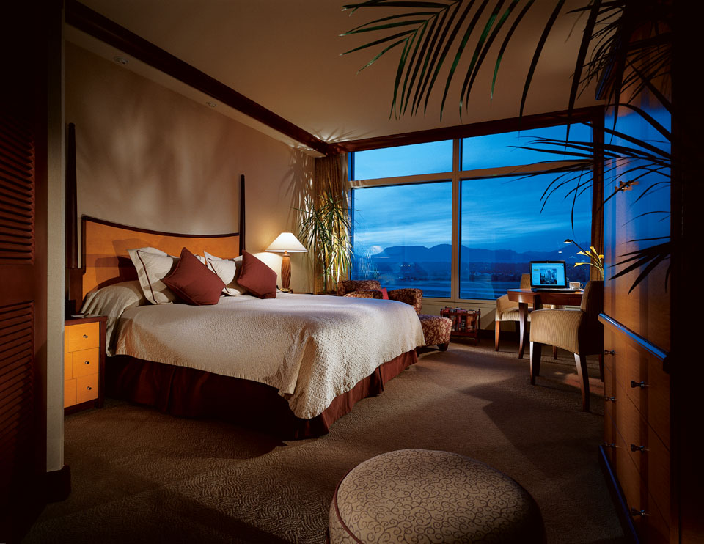
Your field trip will help you see what it is like to work in a hotel. Your teacher will lead you through all the facilities and help you with any questions you may have. Working for a hotel can be exciting, and by understanding how a hotel works, you will know what kinds of duties an IT technician may have while working for a hotel.
Complete the worksheet on the following page. Don’t be afraid to ask questions and learn all that you can about the hotel business.
Rubric:
Evaluation | Marks
Field Trip Worksheet  - Student has completed all the questions on the worksheet  - Student wrote a proper summary using complete sentences and punctuation  - Spelling and grammar are correct | 1 2 3  1 2 3 4  1 2 3
Final | Final Mark out of 10: /10

Field Trip Worksheet
Your name: _________________________ Class: ___________________________

- What is the name of the hotel you are visiting? __________________________________

- What city is the hotel located in? __________________________________

- Use three words (adjectives) which best describes the hotel:

- ____________________ 2) ______________________ 3) ________________________

- What kinds of hotel rooms do they offer to customers? ______________________________
__________________________________________________________________________________
__________________________________________________________________________________
- List some of the facilities the hotel provides for customers:

_______________________ _______________________ _________________________
_______________________ _______________________ _________________________
- What do you think is the most interesting feature of the hotel?
__________________________________________________________________________________
__________________________________________________________________________________
- What job do you think an IT technician would have at this hotel?
__________________________________________________________________________________
__________________________________________________________________________________
- Describe what the hotel logo looks like. What is on the design? What colours are on the logo?
__________________________________________________________________________________
__________________________________________________________________________________
- Write a summary descriptive paragraph on the hotel you visited. Review on how to write a descriptive summary paragraph with your teacher. Be sure that your descriptive paragraph is around 100 words. Below your descriptive paragraph, draw a small picture of one of the descriptions you talked about.

Descriptive Paragraph
Picture of your Descriptive Paragraph

Evaluation 5: Hotel Logo and Mission Statement (15 Marks)
(Due Date: Nov 16-17)
The Details of this Project:
Does the idea of being an IT technician interest you? Does the hotel business appeal to you? The grade 9 Enrichment project will now focus on combining careers in the IT field and hotel business into a fun and exciting project.
- You are invited to help the new owners of a hotel improve their operations by completing tasks which should increase business.
- You will have two semesters to complete all of these tasks. Tasks will be set by your teacher and will be due in the order that they are assigned.
- At the end of the entire project, you and your team will present all of the information and pieces you have created along the way in a large group in the form of a report. You must keep careful records of each individual task, organize your time well, and contribute well to your team.
- You will be graded on individual tasks, completion of those tasks, being on-time, group participation, your design and ideas, and other goals set by your teacher.

The Hotel you are assigned to Improve:
- The Seaside Hotel is located in a magnificent setting overlooking the Arabian Sea. It has a private, sandy beach and a large outdoor swimming pool.
- The hotel has 24 double rooms, 6 family rooms (sleeps 2 adults and 2-4 children), 10 single rooms, and one penthouse suite (sleeps 6-10 adults and includes kitchen and formal living room).
- The hotel has a superb first-floor dining room with a large glass wall overlooking the magnificent sea view. It also has a large lounge and breakfast area, a basement games room, and a large unused area which could be changed into a fitness area/spa facility in the future.
- There is a very good team of workers at the hotel including a concierge, reception staff, a night porter, an excellent chef and kitchen staff, restaurant waiters/waitresses, maids, and maintenance workers.
- Individually students are to create a power point presentation relating to their past hotel experience. The power point should include the following:
- Think about some of your past hotel experiences. Where was the hotel? What did you do there? What kinds of things were offered at the hotel?
- What made your hotel experience positive? Give details and say why.
- What made your hotel experience negative? What would you change and why?
- Get into a group and make a list of qualities and services that you think the “perfect hotel” would have
Features that Make the “Perfect” Hotel
1
2
3

- Students are then required to create a new Logo for the hotel. The new logo should be in colour and completed on a poster size hard copy (A2 size). Please read the description of the hotel on the second page to have an idea of what to present as your logo. The logo should have the following details:

- The hotel name
- Planned out colour combinations (Ex. Orange can represent the sun or sand)
- A new creative slogan (Ex. Super Hotel: A place of relaxation and comfort)
- A mission statement which is a short paragraph on what the group plans to do to help improve the hotel (100-150 Words)
A brief 5 minute presentation on why you chose this logo, the choice in colour and design, explanation of tasks each group member was in charge of and explaining the mission statement.
Students are to review how to properly present in front of an audience using the list provided with Evaluation 2. Teachers are recommended to review these expectations through oral speaking informal assessments.
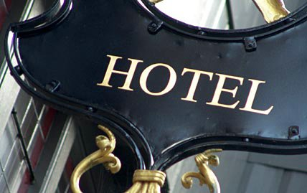
Rubric:
Evaluation | Marks
Logo and Mission Statement  - Logo is colourful and neat  - Logo is modern and relates to hotel  - Hotel Slogan is original and interesting  - Mission statement outlines the main focus of the project | 1 2 3 4 5 6 7  1 2 3 4 5 6 7  1 2 3  1 2 3
Oral Presentation  - Student has a clear and loud voice  - Student uses a variety of vocabulary words  - Student posture is proper and formal | 1 2 3 4  1 2 3  1 2 3
Final | Total /30  Final Mark out of 15: /15

Semester 2: Analyzing the Problems at Seaside Hotel
In semester 1, grade 9 students researched several career opportunities and were introduced to the IT technician profession. The second part to the grade 9 Enrichment book is designed to have students use what they learned in semester 1, creativity, understanding of new vocabulary and media skills to view a hotel which is looking to improve itself and become a more modern business.
Students will be challenged to use problem solving higher level thinking, while having the chance to be creative and use more of their writing skills to develop new plans for “Seaside Hotel”. Teachers are recommended to keep students within their original groups from semester 1, as this semester will have a higher emphasis on group work and class cooperation.
For semester 2, students will be required to conduct research on the internet, create a brochure, learn to write a proper formal email and create a website. Internet access is of importance for this learning cycle and should be available for students during class time.
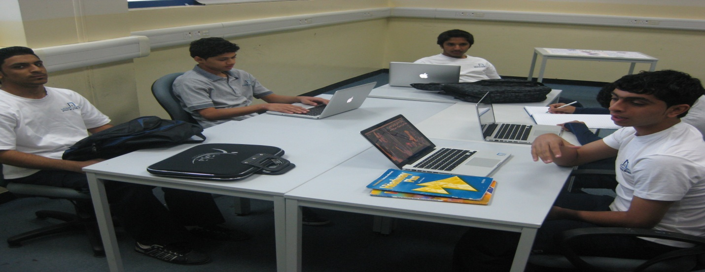
Evaluations for Semester 2:
Evaluation | Due Date | Marks
- Reflection and Vocabulary Semester 2 | Jan 11-12 | 5 Marks
- Customer Needs Analysis Email | Jan 25-26 | 10 Marks
- Hotel Brochure | Feb 8-9 | 15 Marks
- Website Analysis | Feb 15-16 | 5 Marks
- Hotel Website/Presentation | Feb 29-March 1 | 15 Marks
Total 50 Marks
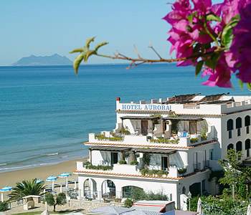
Until Now:
- Students have researched general careers and the IT technician career
- Students have looked back upon past experiences dealing with hotels and have shared positive and negative feedback with the class
- Students have created an attractive new logo and design for their hotel and have composed a new motto or slogan
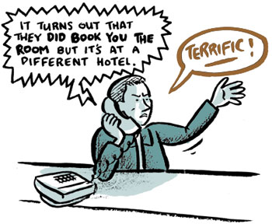
- Students have read and understood the general layout and improvements needed for “Seaside hotel”

A Review of Seaside Hotel:
- The Seaside Hotel is located in a magnificent setting overlooking the Arabian Sea. It has a private, sandy beach and a large outdoor swimming pool.
- The hotel has 24 double rooms, 6 family rooms (sleeps 2 adults and 2-4 children), 10 single rooms, and one penthouse suite (sleeps 6-10 adults and includes kitchen and formal living room).
- The hotel has a superb first-floor dining room with a large glass wall overlooking the magnificent sea view. It also has a large lounge and breakfast area, a basement games room, and a large unused area which could be changed into a fitness area/spa facility in the future.
- There is a very good team of workers at the hotel including a concierge, reception staff, a night porter, an excellent chef and kitchen staff, restaurant waiters/waitresses, maids, and maintenance workers.
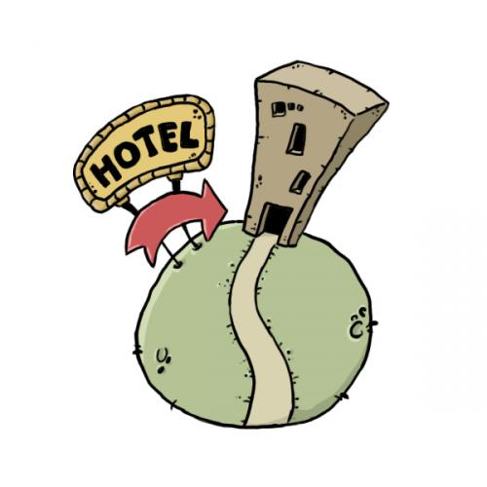

Evaluation 1: Reflection and Vocabulary Semester 2 (5 Marks)
(Due Date: Jan 11-12)
___________________________________________________________________
- Student Reflection
Did Students find success or difficulty in semester 1? For a teacher and a student to become a better learner, looking over your past work and finding your weaknesses and strengths, can help you achieve greater success. Complete the questions below concerning your previous work and your peers. Please be honest with yourself and your teacher when completing this reflection.
Student Name: ________________________________________________

Members of your group: 1) __________________ 2) __________________

3)___________________ 4) _________________ 5) __________________
- Your teacher has reviewed your semester 1 Mark. How do you feel about your mark? Do you believe it is a fair mark? Why or why not?

- What mark would you give yourself out of 10 for the work you have done in semester 1? Be honest!: ________

- Did you have a leader in the group? Who was it? What did they do to help your group?

- What part of the assignment did you find difficult?

- Did this assignment help you with your English? Do you think this assignment is a good assignment to help you improve your English? Why or why not?

- What could the teacher do next time to help you more on the project?

- How can you improve for semester 2? What changes do you plan to make? (Very important question: answer fairly)

- Was the teacher clear with the instructions? Did the teacher give a due date?

- What did you like about the project and what did you not like? Please tell me what you would add to make this a BETTER project (while improving your English and technology skills)?

- Finally, write down one or two things you plan to do better in semester 2:

________________________________ and _____________________________________

- Vocabulary for Semester 2
There will be new vocabulary words introduced in semester 2. This is a list of several of the new words students will be required to know. Under each of the following vocabulary words, students are to write the definition of the word, and provide a sentence to which they clearly show they know the meaning of the word. Students are recommended to write their own definition of the word, rather than simply memorize a given definition from the dictionary.
Vocabulary Word |  | Part of Speech | Definition | Example Sentence
Ex. Scanner |  | Noun | A device used to scan a document and create a digital copy. | John used the scanner to copy his picture and store it into his hard drive.
Weak
Formal
Discuss
Appropriate
Prompt
Modern
 | Attract
 | Promote
 | Compliment
 | Luxury
 | Suite
 | Facility
 | Location
 | Promotion
 | Memory
 | Encourage
 | Unique
 | Access

Rubric:
Evaluation | Marks
Vocabulary  - Definitions are accurate and written in the student’s own words  - Sentences show student’s understanding of the word  - Part of Speech is identified correctly | 1 2 3 4 5  1 2 3 4 5  1 2 3 4 5
Reflection  - Reflection is complete with full answers | 1 2 3 4 5
Final | Total /20  Final Mark out of 5: /5

Evaluation 2: Customer Needs Analysis Email (10 Marks)
(Due Date: Jan 25-26)
- Students are to write an email responding to how you (the IT Technician) intend to change the hotel and modernize it. The hotel needs you to write a proposed plan on how to intend to deal with its current issues. Discuss ideas and solutions to deal with each issue. Each student in the group is responsible in answering each problem in a 100 word paragraph. Therefore the entire email will be around 400 words. Read the description below of the problems the hotel would like you to solve.

Problem 1 (Group member 1)
- The hotel is making a small profit, but is rarely full and not making the most of its superb facilities, location, and staff.

Problem 2 (Group member 2)
- The hotel logo is very outdated and old-fashioned. The hotel needs a new logo and mission statement to attract guests.

Problem 3 (Group member 3)
- The hotel does not have a good method for advertising. It needs a new brochure and website to promote itself on the Internet.

Problem 4 (Group member 4)
- The past guest list needs to be updated into a spreadsheet for easy mailing and sending promotional information to. How do you plan to organize this document and with which program?

Problem 5 (Entire Group)
- A new budget spreadsheet to work out staff salaries must be created and entered into the operating system. How do you plan to organize this tracking sheet?

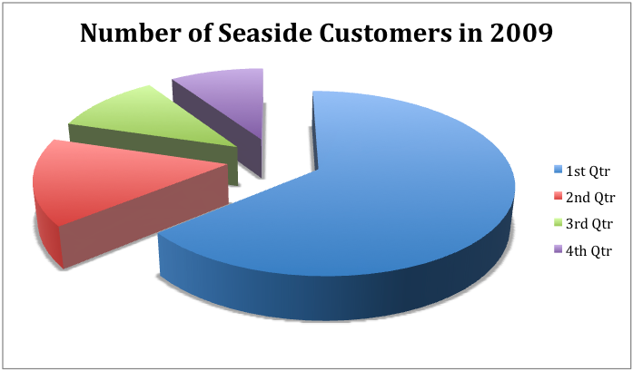
Students are to complete the email by the due date, answering these issues. Groups are to send their emails to the teacher directly. Each problem must be answered the email in a separate paragraph. Therefore your email should look like the following:

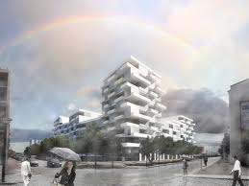
- An introduction : Introduce yourself as an IT Company
- Your plan for Problem 2
- Your plan for Problem 3
- Your plan for Problem 4
- Your plan for Problem 5
- A conclusion

Your teacher will provide you with examples and the proper structure in preparing a formal email. Each member of the group will be responsible for a section of the email and as before, please be sure not to copy information from the internet, or from another student’s work. Also, be sure to send your email on time. As your employer, the hotel expects you to be on prompt with all your work.
Your email should be:
- MINIMUM 400 Words- each student is responsible to write a 100 word response (Marks will be lost for emails shorter than this)
- Neat and formal
- Fully discusses the plan in how to solve the problems listed
- Must have appropriate introduction and conclusion
- Must be emailed to the teacher (your employer on the due date)
Rubric:
Evaluation | Marks
Email  - Email is a minimum 400 words  - The Email is divided properly into 5 paragraphs- each paragraph discussing proposed changes to be made  - Spelling/Grammar  - Ideas are creative and well explained  - Email is in the correct format | 1 2 3  1 2  1 2 3 4  1 2 3 4  1 2 3 4  1 2 3 4 5 6 7 8 9 10  1 2 3
Final | Total /30  Final Mark out of 10: /10

Evaluation 3: Hotel Brochure (15 Marks)
(Due Date: Feb 8-9 )
- In their groups, students are to create an interesting, creative and captivating Hotel brochure. Students are to meet with their team and discuss the specific features their hotel will have:
- Think about what kind(s) of restaurants and facilities you would have available for your customers
- What would be the costs and expenses of your hotel? How much would a one bedroom suite cost? How much would you charge for a luxury suite? How much would breakfast cost? Would you offer complimentary meals? Would you have any shops in your hotel?
- Where will you build your hotel? What directions will you provide on your brochure to direct customers to your hotel? What would your map look like? What highways or main roads are near your hotel?
- What colours, pictures and format will you use to make your brochure look professional and attractive? What can you add to your brochure to make it more appealing than other hotels?
- Your hotel brochure should follow the standard 1 page (6 division) layout. Each page should clearly explain one major aspect of your hotel. The expectations for each page are provided below:

- A cover page that includes your hotel logo, motto/slogan and the name of the student
- A page explaining the facilities
- A page explaining the restaurants/menus and food available
- A page explaining the costs of the hotel (costs of rooms/events)
- A page explaining the location of the hotel (precise, simple directions with a map)
- A page explaining special offers and promotions or any additional information

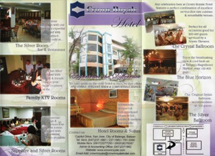
- Once students have completed their brochure, they are to make sure they have met the following requirements (check each circle):

- Each section of the brochure has a minimum of 50 words
- Each section of the brochure has a clear title
- Student name and class is clearly identified on the cover page
- Student has reread and edited their brochure for mistakes
- Student uses complete sentences and avoids using point form for most sections of the brochure
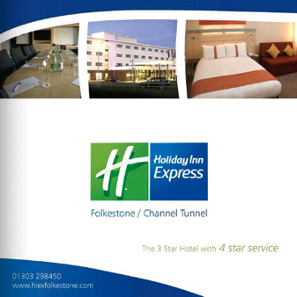

Rubric:
Evaluation | Marks
Creativity/Content  - Brochure has appropriate content  for each feature  - Brochure is professional and attractive  - Proper map and images are added | 1 2 3 4 5  1 2 3  1 2 3
Mechanics  - Spelling and sentence structure  - Capitals and punctuation used correctly  - Directions are clear and simplified for clarity  - Students have met the 50 word guideline for all sections of the brochure | 1 2 3 4 5  1 2 3 4 5  1 2 3 4  1 2 3 4 5
Final | Total /30  Final Mark out of 15: /15

Evaluation 4: Website Analysis (5 Marks)
(Due Date: Feb 15-16)
Students are to view the listed travel industry websites and rate on how effective the websites are. Complete the chart below by rating each website. Since you will be creating your own hotel website, it is important to view other similar websites and find features which make the website effective or not effective. Remember- A well prepared and organized website will bring better business to Seaside Hotel.

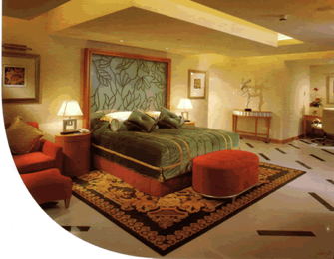
*View additional handout for Website Analysis chart
Teachers are to inform students on how to comment and criticize appropriately in English. Students are recommended to use different forms of vocabulary in discussing what they felt was well done or poorly done on each website.

Rubric:
Evaluation | Marks
Website Analysis  - Student prepares a thorough explanation on the positive aspects for each website  - Student explains a thorough explanation on possible improvements for each website  - Student writes in complete sentences in their explanations  - Student provides complete and thorough feedback for all websites | 1 2 3 4 5  1 2 3 4 5  1 2 3 4 5  1 2 3 4 5
Final | Total /20  Final Mark out of 5: /5

Website Analysis Page 1
Complete the Chart Below by Viewing the Websites. Write complete sentences for your answers.
 | Website 1) EXAMPLE  http://www.daysinn.com/DaysInn/control/home | Website 2)  http://www.starwoodhotels.com/alofthotels/property/overview/index.html?propertyID=3353 | Website 3)  http://www.citycoastcountryside.co.uk/site/historic-lancaster
Site Name | Days Inn Homepage
Things I like about the Site | The website is colourful and has many links to other hotels.  The webpage is clear and organized. It is easy to find what you are looking for.
Things that Need Improvement | The calendar on the webpage is small and difficult to see.  Prices are not always clearly shown.
Titles of Links to other Pages | Home, Hotels and Reservations, Special Offers, Wyndham Rewards and Email
Two (2) new English Words on the website that I learned | - Advance: To go forwards  - Reward: A gift for doing something well
Advertisements I Found on this webpage | Windham rewards and Ramada Hotel have advertisements on this webpage.  Some other links lead to other advertisements to Geiko Car Insurance.
My Star Rating (1 to 5 Stars)
Website Analysis Page 2
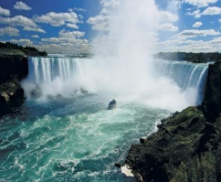 | Website 4)  http://www.sunbridgecres.com/ | Website 5)  http://www.niagarafallstourism.com/ | Website 6)  http://www.bellagio.com/
Site Name
Things I like about the Site
Things that Need Improvement
Titles of Links to other Pages
Two (2) new English Words on the website that I learned
Advertisements I Found on this webpage
My Star Rating (1 to 5 Stars)

Website Analysis Page 3
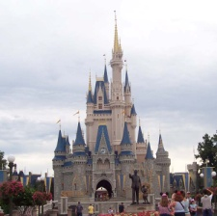 | Website 7)  http://www.visitcalifornia.com/ | Website 8)  http://www.thealamo.org/ | Website 9)  http://disneyworld.disney.go.com/
Site Name
Things I like about the Site
Things that Need Improvement
Titles of Links to other Pages
Two (2) new English Words on the website that I learned
Advertisements I Found on this webpage
My Star Rating (1 to 5 Stars)

Evaluation 5: Hotel Website/Presentation (15 Marks)
(Due Date: Feb 29-March 1)
- Now that students have had the opportunity to view several websites and discuss what makes an organized website, students will be challenged to create their own Seaside Hotel website. Students are encouraged to collaborate with their group members on design ideas, weblinks and other features they wish to incorporate into their webpage.

- Students are advised to locate an effective webpage link to which they can begin to plan their new Seaside homepage. There are several sites which offer free webpage design templates and your teacher will introduce several such sites. Several additional website addresses have been listed below for students to view.

Website | Link Address
Zeta-Producer | http://www.fileguru.com/Zeta-Producer-Desktop/download
Weebly | http://www.weebly.com
Webstarts | http://www.webstarts.com

Students are encouraged to use the same subtitles for their website as they used in their brochure. Essentially, students are to take the summarized information of their facilities, restaurants, promotions, etc and create a more thorough explanation for each of these elements of the hotel. Students are encouraged to add additional pages to their website such as a comments page, guestbook, etc.

Requirements: Students are to create a website containing the following:

- A minimum of 6 pages for the website (feel free to use the same layout as the brochure, using the same headings)
- Students must have a minimum of 3 links to other pages which are related to their hotel
- Students must have a feedback or guestbook section on their website
- Students must have a complete map/blueprint of the hotel and the location of all the facilities
- Students will be marked on creativity and uniqueness of their webpage- professionalism and proper format will also be assessed
- Although students may be working in groups, each student is required to post their hotel logo on the hotel homepage and clearly present the changes they made to the hotel as according to their plans and email.

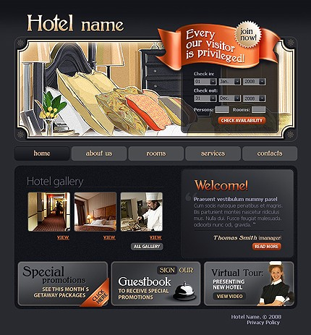
- The hotel webpage is to be submitted electronically to the teacher once completed. Students and teachers are highly encouraged to share their websites afterwards.

Rubric:
Evaluation | Marks
Website Format  - Website is organized, formal and easy to navigate through including links  - Images and titles are clearly displayed  - Each webpage is a thorough expansion of each of the elements presented in the brochure  - Creativity and general Attractiveness of website | 1 2 3 4 5 6  1 2 3  1 2 3  1 2 3 4 5 6
Mechanics  - Capitalization for all names, places and titles/ proper punctuation present  - Spelling, proper paragraphs, sentence structure is correct | 1 2 3 4 5 6  1 2 3 4 5 6
Final | Total /30  Final Mark out of 10: /10

- Students are to present their website to the class in a formal oral presentation. Emphasis on clarity, fluency and formality are emphasized. Presentations should be thorough as content and length are also to be evaluated. Teachers are to review the proper ways to present a formal presentation.
Rubric:
Evaluation | Marks
Presentation  - Student posture, formality, organization  - Student presentation is 5-10 minutes  - Student has appropriate eye contact and presents information rather than reciting | 1 2 3  1 2 3  1 2 3
Mechanics  - Student speaks clearly and fluently  - Voice tone and volume is acceptable  - Vocabulary is academic and varied | 1 2 3 4  1 2 3  1 2 3 4
Final | Total /20  Final Mark out of 10: /5

Semester 3: Creating Solutions
Students have now had the opportunity to creatively plan out and prepare the initial plans in upgrading Seaside hotel. Through the email, reflection of the issues regarding the hotel, brochure and website, students are now in the final stages of finalizing their project. As with many future projects, students will be responsible to write a final report discussing their final work. The formal report will introduce grade 9 students how to write a summary of their completed work, and how to present it in a neat and organized document.
In this semester, students will complete the final plans on how to network several devices within the hotel ground floor. Students will be taught the basic proper methods on networking through workshops and research and then show what they have learned through a map of their hotel. Students will also be required to prepare an Excel spread sheet which presents the hotel salaries, employees and other costs. Finally, students will combine all their previous work, in an organized report which will be handed in as their final evaluation.
Teachers are strongly recommended to keep students in their original groups so that the final projects can be consistent with the cooperative work they have completed throughout all three semesters.
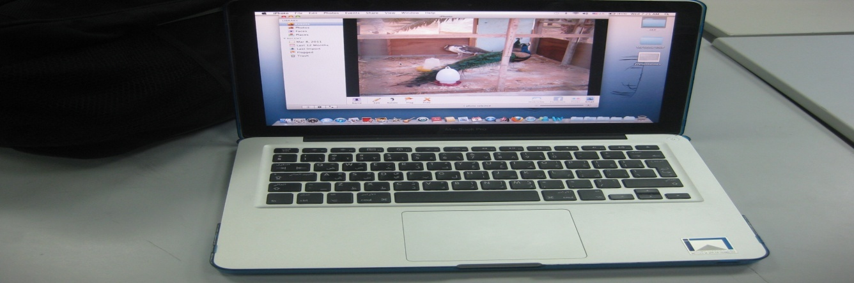
Evaluations for Semester 3:
Evaluation | Due Date | Marks
- Reflection and Vocabulary Semester 3 | April 15-16 | 5 Marks
- Flow Chart of IT Systems | April 29-30 | 10 Marks
- Excel Salary Worksheet | May 9-10 | 10 Marks
- Report Writing Format | May 20-21 | 5 Marks
- Finalized Hotel Report and Presentation | June 6-7 | 20 Marks
Total 50 Marks

Evaluation 1: Reflection and Vocabulary Semester 3 (5 Marks)
(Due Date: April 15-16)
___________________________________________________________________
- Student Reflection
Did Students find success or difficulty in semester 2? Please be honest with yourself and your teacher when completing this reflection.
Student Name: ________________________________________________

Members of your Group: 1) __________________ 2) __________________

3)___________________ 4) _________________ 5) __________________

- Your teacher has reviewed your semester 2 Mark. How do you feel about your mark? Do you believe it is a fair mark? Why or why not?

- What mark would you give yourself out of 10 for the work you have done in semester 2? Be honest!: ________

- What two things did you write down that you wanted to improve on in semester2?

_________________________________________ ____ and ____________________________________________

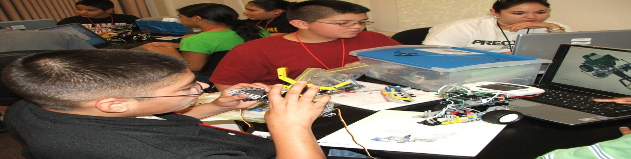

- Did you improve on these two things in semester 2? Why or why not?

- What do you think you did well on this semester? Why do you think you did well on this part?

- Did the assignments in semester 2 help you with your English? Why or why not?

- What could the teacher do next time to help you more on the project?

- What is one goal you will make for yourself for semester 3? How will you make sure you do this?

- For next year’s students, what advice would you give them, to make sure they do a good job on the project?

Thank You
- Vocabulary for Semester 3
There will be new vocabulary words introduced in semester 3. This is a list of several of the new words students will be required to know. Under each of the following vocabulary words, students are to write the definition of the word, and provide a sentence to which they clearly show they know the meaning of the word. Students are recommended to write their own definition of the word, rather than simply memorize a given definition from the dictionary.
Vocabulary Word |  | Part of Speech | Definition | Example Sentence
Ex. Scanner |  | Noun | A device used to scan a document and create a digital copy. | John used the scanner to copy his picture and store it into his hard drive.
Wage
Financial
Recommend
Simple
Complicate
Furniture
 | Network
 | Collapse
 | Shiny
 | Tough
 | Swerve
 | Mature
 | Elegant
 | Hue
 | Concentrate
 | Reference
 | Isolate
 | Support

Rubric:
Evaluation | Marks
Vocabulary  - Definitions are accurate and written in the student’s own words  - Sentences show student’s understanding of the word  - Part of Speech is identified correctly | 1 2 3 4 5  1 2 3 4 5  1 2 3 4 5
Reflection  - Reflection is complete with full answers | 1 2 3 4 5
Final | Total /20  Final Mark out of 5: /5

Evaluation 2: Flow Chart of IT Systems (10 Marks)
(Due Date: April 29-30)
- Students are to complete a flow chart, outlining their plan on how to network the hotel’s systems together. An example of a flow chart is provided below:

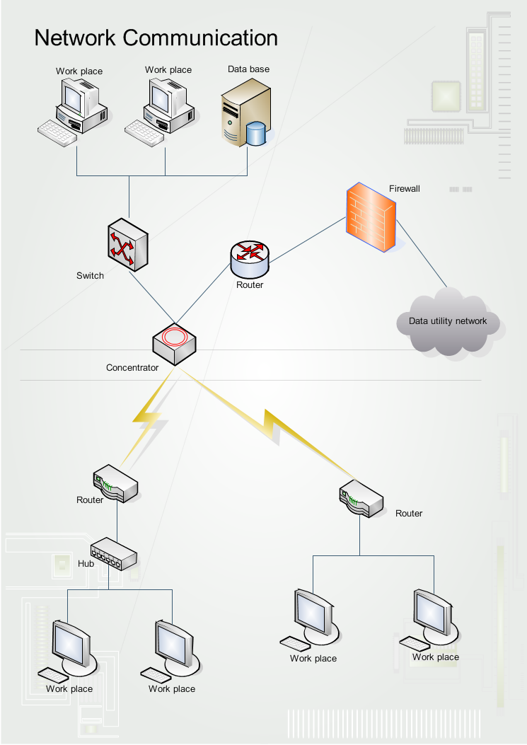

You are to create a flow chart on the systems you wish to install in the hotel. You must provide a clear basic map of the first floor of your hotel, where each computer/printer would be set up, and how each system would be linked. A hard copy print out of this assignment is to be handed in to the teacher, with each part of the flowchart clearly labeled and organized. An example will be provided by the teacher. The hardware and location of each device is provided below.
Students can be creative with their flowchart and map. They are to use a variety of colour, arrows, shapes and lines to show how their networking system would look like on the first floor of their hotel. Students should also include furniture such as sofas, desks, tables, plants, etc. while also labeling each room.
Hardware | Location | What it will be used for
Computer  Computer (2) | Reception | Booking rooms for customers.  Checking bookings for customers and emailing customers/ other members of staff.  Getting onto the internet to check various travel information.
Printer | Reception | Printing out various documents and bills for customers.
Computer | The Office | To do various administration tasks such as letters and bills.
Printer (s) | The Office | Printing out various documents such as high quality letters.
Scanner | The Office | The hotel will use this instead of a photocopier.
Computer | Hotel Lounge | For hotel guests to access the internet and use email.
A switch box | The office | To connect computers together.

Rubric:
Evaluation | Marks
Flowchart of Technology  - Flowchart accurately labels all tech  - Flowchart includes map of hotel and where every component is located  - Flowchart is organized, colourful  - Flowchart is clearly labeled | 1 2 3 4  1 2 3 4  1 2 3 4  1 2 3
Chart of Proposed Changes  - Chart is filled in entirety with detail  - Spelling, Paragraphs, Mechanics  - Ideas are creative and complete | 1 2 3 4 5  1 2 3 4 5  1 2 3 4 5
Final | Total /30  Final Mark out of 10: /10

Evaluation 3: Excel Salary Worksheet (10 Marks)
(Due Date: May 9-10)
Paying employees and recording wages needs a lot of organization. By using an Excel worksheet, students can learn how to record expenses in a company in an easy to follow form.

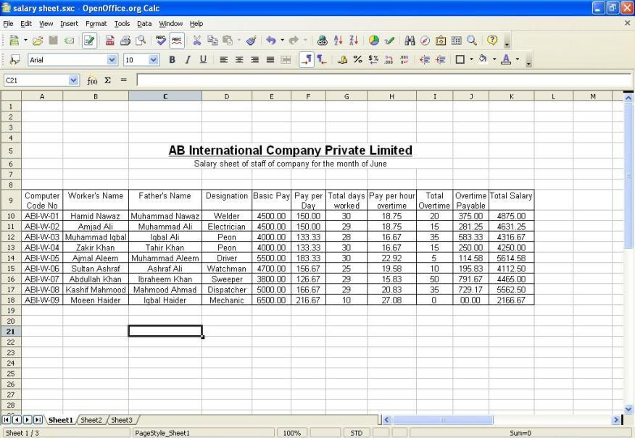
In this part of the project, you will do two things:
- You will practice how to use a spreadsheet
- You will design a spreadsheet to keep track of the of the Seaside Hotel’s employee hours and salaries
Complete the following tasks below in the steps provided. This will allow students to understand how to prepare a spreadsheet in an easy to follow, step-by-step method. There are 8 mini activities which students will be required to complete. Each activity will be assessed in the class and marked by the teacher for completeness.
Activity 1
- Students are to think about spreadsheets. What do they know about them? Write the answers for these introduction questions below.

- What is a spreadsheet and what do we use them for?
- What programs do we use?
- What do we want the spreadsheet to do for Seaside hotel?

- Let’s work with the spreadsheet. Open Microsoft Excel
- Press file- click on “Save As” and name the spreadsheet “Your name- Spreadsheet Assignment”
- Make a folder called “Hotel Spreadsheet” and put it on your desktop.
- Save “Spreadsheet Assignment” in the Hotel Spreadsheet folder
- Open assignment “Spreadsheet Assignment” and type the title “Seaside Hotel: Employee Spreadsheet.” You can choose the font, size, colour and position. Remember, this is only a title for the streadsheet and so should not take up the entire screen, or be too small to read.
- Finally, insert at least one copy of the logo you designed for the hotel. You should then save your work and send a copy to your teacher.
